Agile Builder

## Team Members

Snehil Shah

Alefiya Rampurawala

Aditya Sawant

Dhara Shah

## Requirements

1. Workspace
2. Cards in Workspace

# Export to Word/Excel

1. Login
2. Profile Page
3. Roles for Users
4. Templates
5. Ability to Edit Agenda Builder
6. Agenda Calendar

## Literature Survey:

Taiga.io:

<https://www.taiga.io/en>

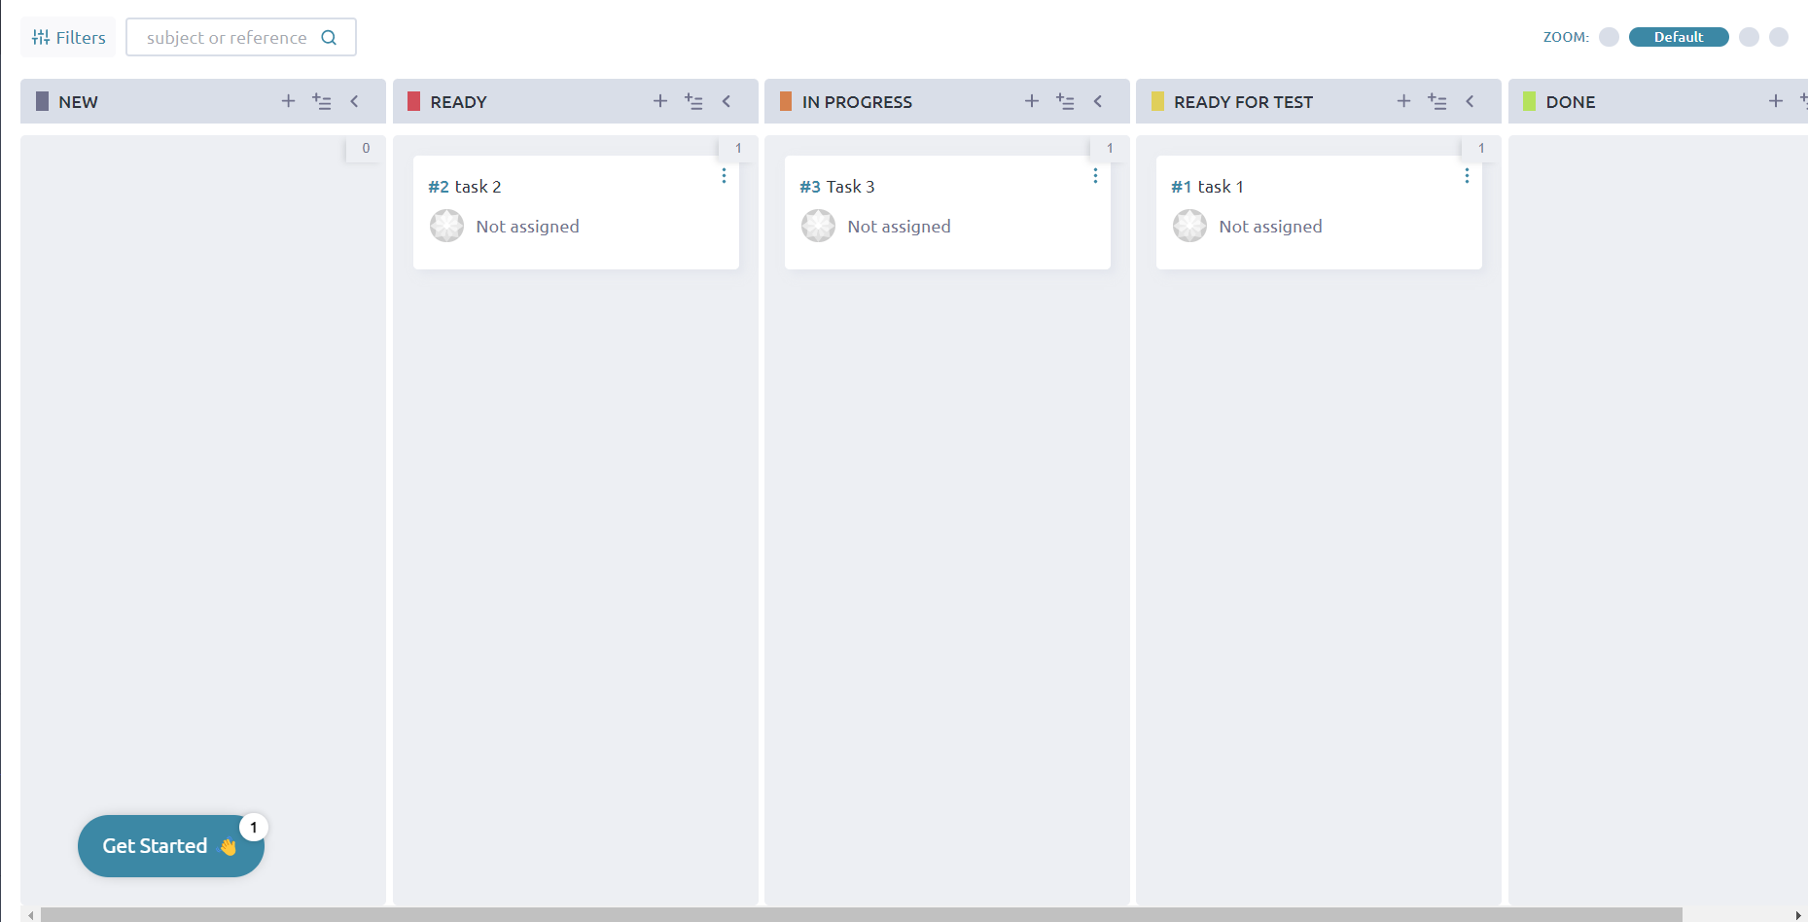

* Minimalistic UI
* Ability to Drag & Drop Tasks
* Comes with 2 templates
* No Roles

Confluence:

<https://start.atlassian.com/>

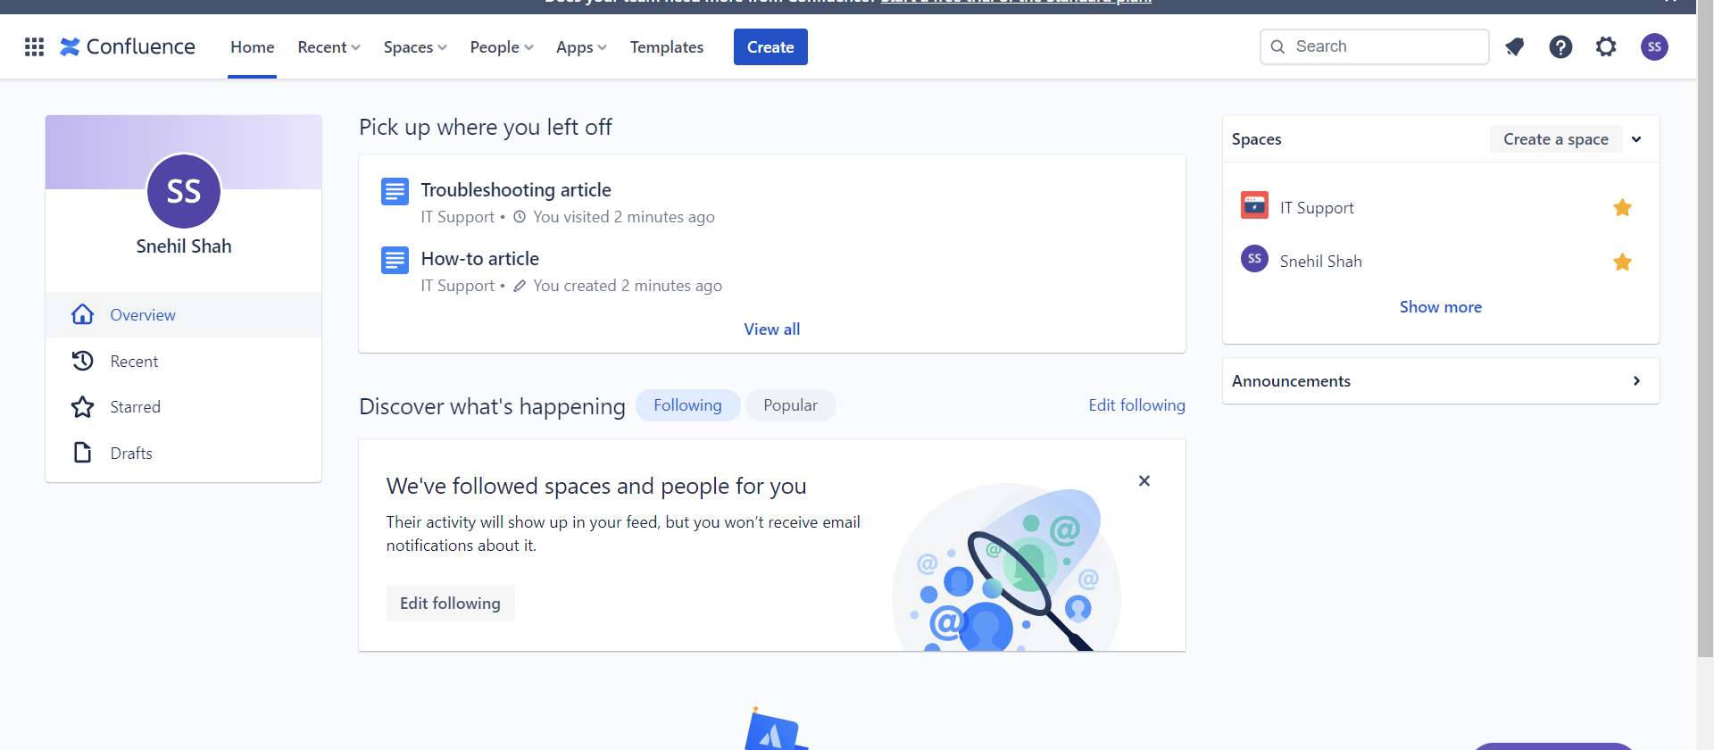

* Good Team Integration
* Good Templates
* No Board View
* Allows Role Management

## Technologies Used:

* React + NextJS
* Tailwind
* Mysql
* Temporary Hosting: https://vercel.com/srshah27/agenda-builder